Graphs of Trigonometry Functions
Function Name | Parent Function | Graph of Function | Characteristics
Sine | $$f\left(x\right)=sin⁡(x)$$ | 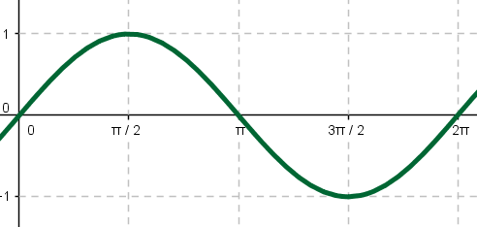 | Domain: $\left(-∞,∞\right)$  Range: $\left[-1, 1\right]$  Odd/Even: Odd  Period: $2π$
Cosine | $$f\left(x\right)=cos⁡(x)$$ | 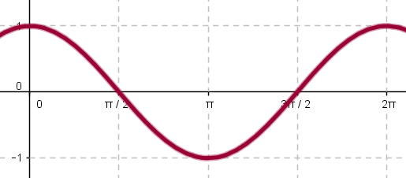 | Domain: $\left(-∞,∞\right)$  Range: $\left[-1, 1\right]$  Odd/Even: Even  Period: $2π$
Tangent | $$f\left(x\right)=\tan\left(x\right)$$  $$=\frac{sin⁡(x)}{cos⁡(x)}$$ | 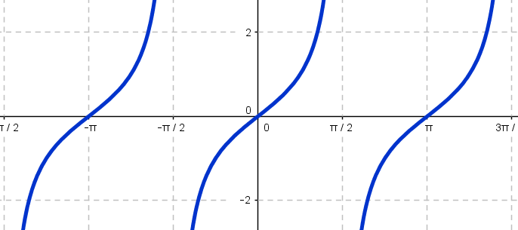 | Domain: $\left(-∞,∞\right)$ except for $x=\frac{π}{2}±nπ$  Range: $\left(-∞,∞\right)$  Odd/Even: Odd  Period: $π$  Asymptotes at $x=\frac{π}{2}±nπ$
Cosecant | $$f\left(x\right)=\csc\left(x\right)$$  $$=\frac{1}{sin⁡(x)}$$ | 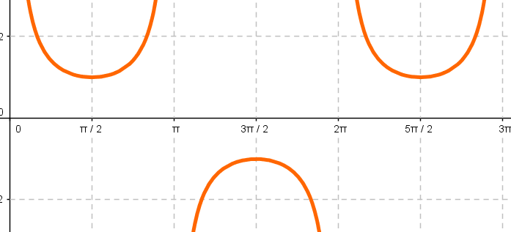 | Domain: $\left(-∞,∞\right)$ except for $x=±nπ$  Range: $\left(-∞, \left.-1\right]\right.∪\left[1,\left.∞\right)\right.$  Odd/Even: Odd  Period: $2π$
Secant | $$f\left(x\right)=\sec\left(x\right)$$  $$=\frac{1}{cos⁡(x)}$$ | 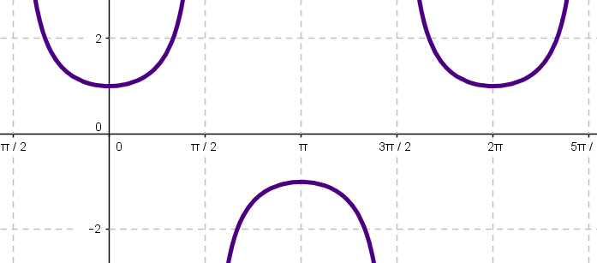 | Domain: $\left(-∞,∞\right)$ except for $x=\frac{π}{2}±nπ$  Range: $\left(-∞, \left.-1\right]\right.∪\left[1, \left.∞\right)\right.$  Odd/Even: Even  Period: $2π$
Cotangent | $$f\left(x\right)=\cot\left(x\right)$$  $$=\frac{1}{\tan\left(x\right)}$$  $$=\frac{\cos{(x)}}{\sin{(x)}}$$ | 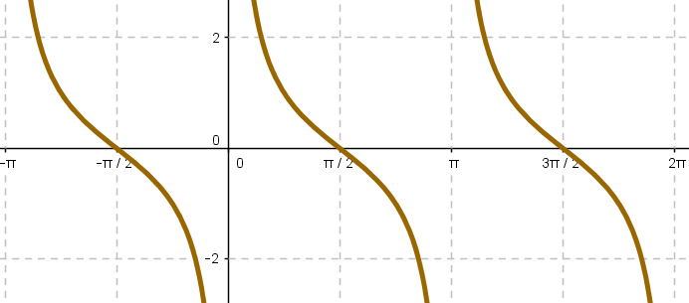 | Domain: $\left(-∞,∞\right)$ except for $x=±nπ$  Range: $\left(-∞,∞\right)$  Odd/Even: Odd  Period: $π$  Asymptotes at $x=±nπ$
General Form: $f\left(x\right)=a\sin\left[b\left(x-h\right)\right]+k$ Note: This general form can be used for any trigonometric function

MVCC Learning Commons Math Lab WH129 Summer 2026

Graphs of Trigonometry Functions
Function Name | Parent Function | Graph of Function | Characteristics
Inverse Sine | $$f\left(x\right)=\sin^{-1}\left(x\right)$$  $$=arcsin⁡(x)$$ | 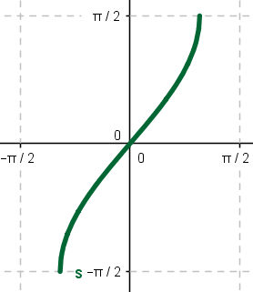 | Domain: $\left[-1,1\right]$  Range: $\left[\frac{-π}{2}, \frac{π}{2}\right]$
Inverse Cosine | $$f\left(x\right)=\cos^{-1}\left(x\right)$$  $$=arccos⁡(x)$$ | 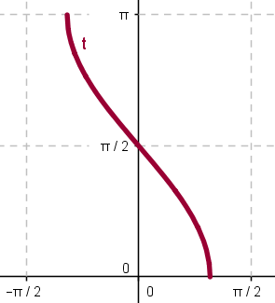 | Domain: $\left[-1,1\right]$  Range: $\left[0, π\right]$
Inverse Tangent | $$f\left(x\right)=\tan^{-1}{(x)}$$  $$=arctan⁡(x)$$ | 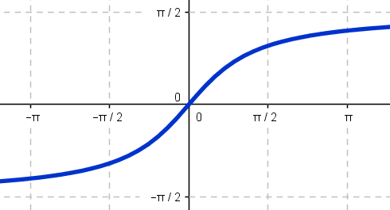 | Domain: $\left(-∞,∞\right)$  Range: $\left(\frac{-π}{2},\frac{π}{2}\right)$
Inverse Cosecant | $$f\left(x\right)=\csc^{-1}{(x)}$$  $$=arccsc⁡(x)$$ | 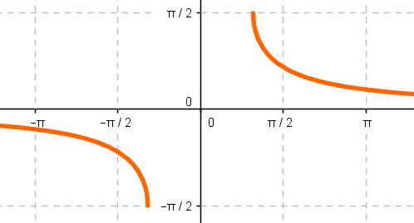 | Domain:  $$\left(-∞,-\left.1\right]\right.∪\left[1,\left.∞\right)\right.$$  Range: $\left[\frac{-π}{2},\frac{π}{2}\right],y≠0$
Inverse Secant | $$f\left(x\right)=\sec^{-1}{(x)}$$  $$=arcsec⁡(x)$$ | 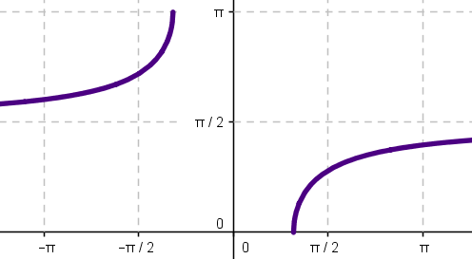 | Domain:  $$\left(-∞, \left.-1\right]\right.∪\left[1, \left.∞\right)\right.$$  Range: $\left[0,π\right], y≠\frac{π}{2}$
Inverse Cotangent | $$f\left(x\right)=\cot^{-1}{(x)}$$  $$=arccot⁡(x)$$ | 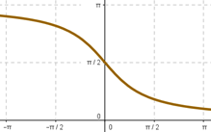 | Domain: $\left(-∞,∞\right)$  Range: $\left(0,π\right)$
MVCC Learning Commons Math Lab WH129 Summer 2026

