The Unit Circle

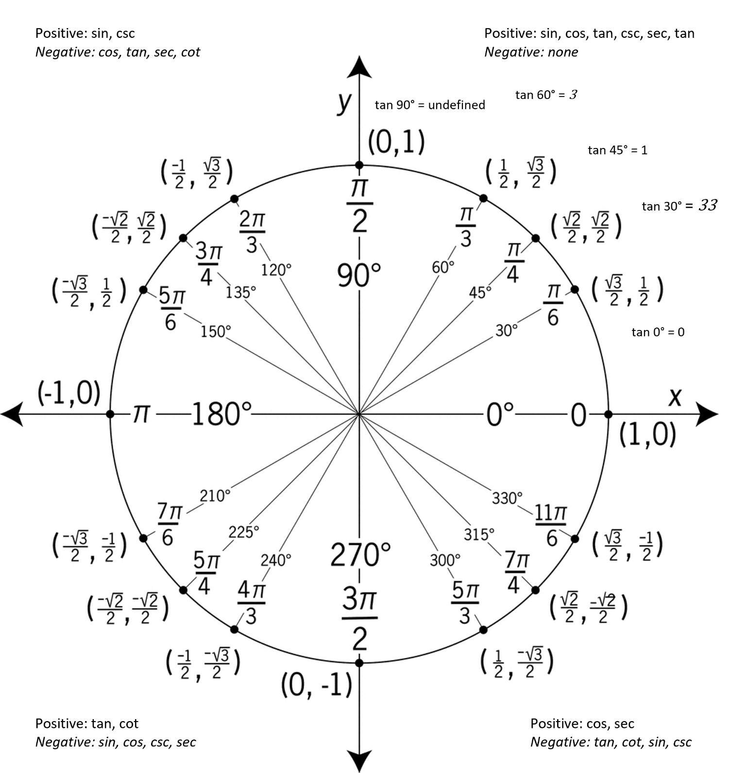

MVCC Learning Commons WH129 Spring 2026

